TEST DES REQUETES POUR CHAQUE TABLE
Nous utiliserons comme interclassement en production soit general_ci, soit utf_8

Table categorie

Création

CREATE TABLE categorie (
id INTEGER UNSIGNED NOT NULL AUTO_INCREMENT PRIMARY KEY,
charac VARCHAR(50) NOT NULL,
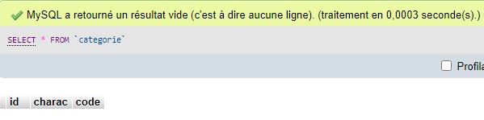
code VARCHAR(10));
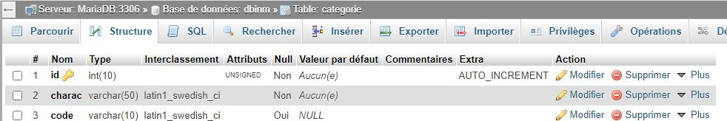

Insert

INSERT INTO categorie (id,charac,code)
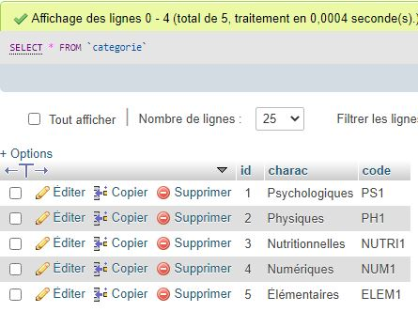
VALUES
(1,'Psychologiques','PS1'),
(2,'Physiques', 'PH1'),
(3,'Nutritionnelles', 'NUTRI1'),
(4,'Numériques', 'NUM1'),
(5,'Élémentaires', 'ELEM1');

Select

Select un champ | Select tous les champs
SELECT charac  FROM categorie  WHERE id = 1 | SELECT *  FROM categorie
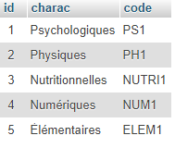
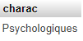
Table sous_categorie

Création

CREATE TABLE sous_categorie (
id INTEGER UNSIGNED NOT NULL AUTO_INCREMENT PRIMARY KEY,
name VARCHAR(50) NOT NULL,
code VARCHAR(10)
categorieID int not null,
FOREIGN KEY (categorieID) REFERENCES categorie (id));

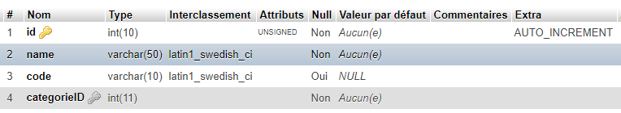
Insert

INSERT INTO sous_categorie (id,name,code,categorieID)
VALUES
(1,'Art Thérapies','xxxxxxxxxx',1),
(2,'Programmes d’éducation santé','xxxxxxxxxx',1),
(3,'Psychothérapies','xxxxxxxxxx',1),
(4,'Pratiques psychocorporelles','xxxxxxxxxx',1),
(5,'Thérapies assistées par l’animal','xxxxxxxxxx',1),
(6,'Programmes d’activité physique','xxxxxxxxxx',2),
(7,'Hortithérapies','xxxxxxxxxx',2),
(8,'Physiothérapies','xxxxxxxxxx',2),
(9,'Thérapies manuelles','xxxxxxxxxx',2),
(10,'Programmes balnéologiques','xxxxxxxxxx',2),
(11,'Compléments alimentaires','xxxxxxxxxx',3),
(12,'Programmes nutritionnels','xxxxxxxxxx',3),
(13,'m-Santé','xxxxxxxxxx',4),
(14,'Thérapies par le jeu vidéo','xxxxxxxxxx',4),
(15,'Thérapies par la réalité virtuelle','xxxxxxxxxx',4),
(16,'Préparations minérales','xxxxxxxxxx',5),
(17,'Préparations mycologiques','xxxxxxxxxx',5),
(18,'Préparations botaniques','xxxxxxxxxx',5),
(19,'Méthodes électromagnétiques','xxxxxxxxxx',5),
(20,'Cosméceutiques','xxxxxxxxxx',5);
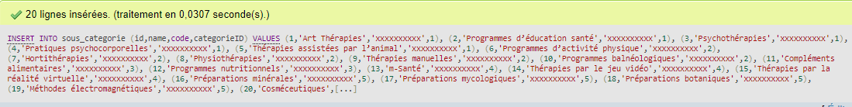
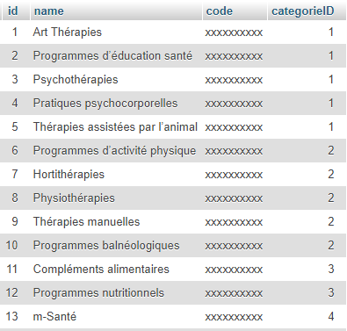

Select

Select un champ | Select tous les champs | Select reference des champs
SELECT name  FROM sous_categorie  WHERE categorieID = 1 | SELECT *  FROM sous_categorie | SELECT s.name  FROM sous_categorie AS s, categorie AS c  WHERE s.categorieID = c.id
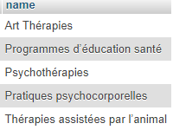
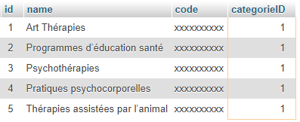
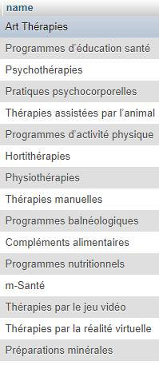

Table maladie

Création

CREATE TABLE maladie (
id INTEGER UNSIGNED NOT NULL AUTO_INCREMENT PRIMARY KEY,
name VARCHAR(50) NOT NULL,
definition TEXT (1000) NOT NULL);
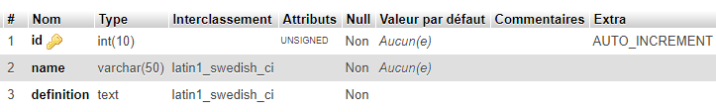
Insert

INSERT INTO maladie (id,name,definition)
VALUES
(1,"Neoplasms","X"),
(2,"Covid-19","X"),
(3,"Bien vieillir","X");
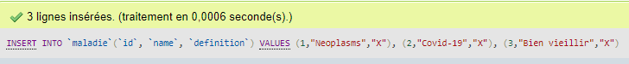
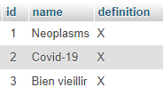
Select

Select un champ | Select tous les champs
SELECT name  FROM maladie  WHERE id = 1 | SELECT *  FROM maladie
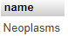
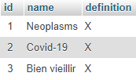

Table NEOPLASMS

Création
CREATE TABLE neoplasms (
id INTEGER UNSIGNED NOT NULL AUTO_INCREMENT PRIMARY KEY,
class VARCHAR(50) NOT NULL,
name VARCHAR(50) NOT NULL,
definition TEXT(1000) NOT NULL,
label VARCHAR(10) NOT NULL,
maladieID INTEGER NOT NULL,
FOREIGN KEY (maladieID) REFERENCES maladie (id));

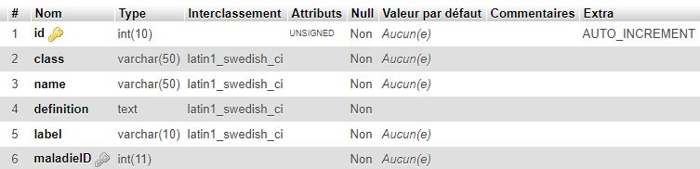
Insert

INSERT INTO neoplasms(id, class, name, definition,label,maladieID)
VALUES (1,'Cancer','Neoplasms1','','',1),
(2,'Cancer','Neoplasms2','','',1),
(3,'Cancer','Neoplasms2','','',1);

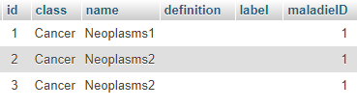
Select

Select un champ | Select tous les champs | Select reference des champs
SELECT name  FROM neoplasms  WHERE maladieID = 1 | SELECT *  FROM neoplasms | SELECT s.name  FROM neoplasms AS s, maladie AS c  WHERE s.maladieID = c.id
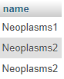
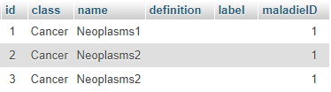
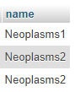

Table COVID-19

Création

CREATE TABLE covid_19 (
id INTEGER UNSIGNED NOT NULL AUTO_INCREMENT PRIMARY KEY,
class VARCHAR(50) NOT NULL,
name VARCHAR(50) NOT NULL,
definition TEXT(1000) NOT NULL,
label VARCHAR(10) NOT NULL,
maladieID INTEGER NOT NULL,
FOREIGN KEY (maladieID) REFERENCES maladie (id));
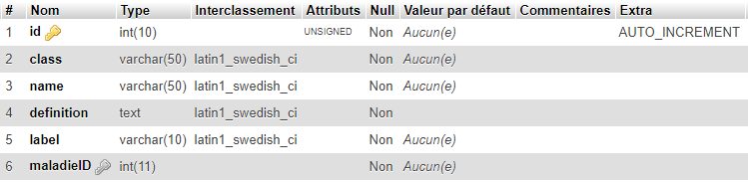
Insert

INSERT INTO Covid_19(id, class, name, definition,label,maladieID)
VALUES (1,'Covid-19','Covid-19 1','','',2),
(2,'Covid-19','Covid-19 2','','',2),
(3,'Covid-19','Covid-19 3','','',2);
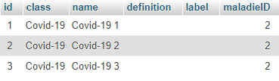
Select

Select un champ | Select tous les champs | Select reference des champs
SELECT name  FROM covid_19  WHERE maladieID = 2 | SELECT *  FROM covid_19 | SELECT c.name  FROM covid_19 AS c, maladie AS m  WHERE c.maladieID = m.id
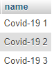
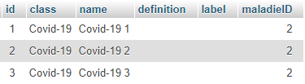
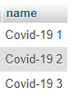
Table Bien_vieillir

Création

CREATE TABLE Bien_vieillir (
id INTEGER UNSIGNED NOT NULL AUTO_INCREMENT PRIMARY KEY,
class VARCHAR(50) NOT NULL,
name VARCHAR(50) NOT NULL,
definition TEXT (1000) NOT NULL,
label VARCHAR(10) NOT NULL,
maladieID INTEGER NOT NULL,
FOREIGN KEY (maladieID) REFERENCES maladie (id));

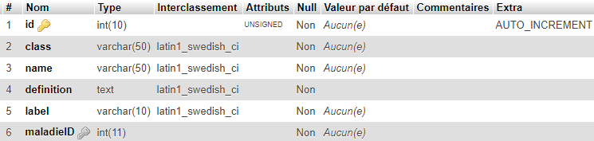

Insert

INSERT INTO Bien_vieillir (id, class, name, definition,label,maladieID)
VALUES (1,'Bien vieillir 1','Bien vieillir','','',3),
(2,'Bien vieillir 2','Bien vieillir','','',3),
(3,'Bien vieillir 3','Bien vieillir','','',3);
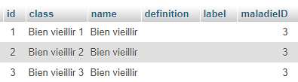
Select

Select un champ | Select tous les champs | Select reference des champs
SELECT name  FROM bien_viellir  WHERE maladieID = 3 | SELECT *  FROM bien_viellir | SELECT c.name  FROM bien_viellir AS c, maladie AS m  WHERE c.maladieID = m.id
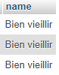
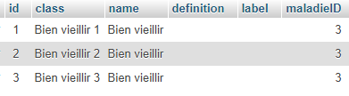
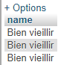

Table INM

Création

CREATE TABLE INM (
id INTEGER UNSIGNED NOT NULL AUTO_INCREMENT PRIMARY KEY,
sous_categorieID INTEGER NOT NULL,
name VARCHAR(50) NOT NULL,
npi TEXT (1000) NOT NULL,
npi_code VARCHAR(50) NOT NULL,
FOREIGN KEY (sous_categorieID) REFERENCES sous_categorie (id));

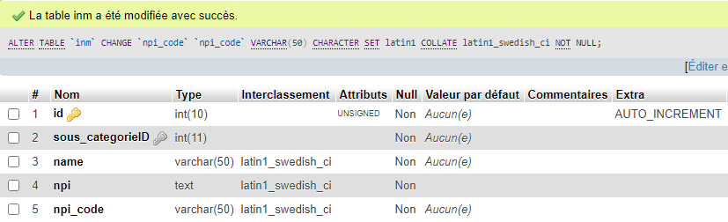
Insert

INSERT INTO INM (id,sous_categorieID,name,npi,npi_code)
VALUES
(1,2,'Themalism related terms','Local aerobath','NPI2.5.1'),
(2,2,'Themalism related terms','Individual aerosol','NPI2.5.1');

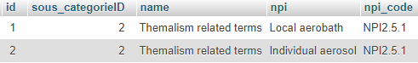
Select

Select un champ | Select tous les champs | Select reference des champs
SELECT name  FROM INM  WHERE sous_categorieID = 2 | SELECT *  FROM INM | SELECT i.name  FROM INM AS i, maladie AS c  WHERE i. sous_categorieID = c.id
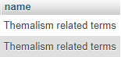
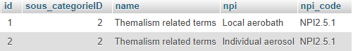
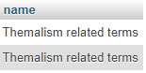

Table HistoMed

Création

CREATE TABLE HistoMed(
id INTEGER UNSIGNED NOT NULL AUTO_INCREMENT PRIMARY KEY,
nom_fichier TEXT (100) NOT NULL,
date_info DATE NOT NULL,
date_enreg DATE NOT NULL,
nombre_lignes INTEGER UNSIGNED NOT NULL);

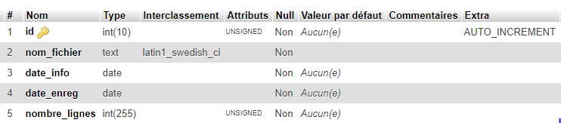
Insert

INSERT INTO HistoMed (
id,nom_fichier,date_info,date_enreg,nombre_lignes)
VALUES
(1,'MedLine120210308','2021-03-08','2021-03-08',1);
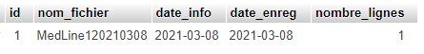
Select
Select un champ | Select tous les champs
SELECT nom_fichier  FROM HistoMed | SELECT *  FROM HistoMed
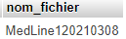
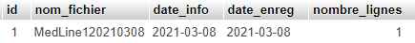
Table EDITEUR

Création

CREATE TABLE EDITEUR(
id INTEGER UNSIGNED NOT NULL AUTO_INCREMENT PRIMARY KEY,
name VARCHAR(50) NOT NULL,
adresseURL VARCHAR(50) NOT NULL);

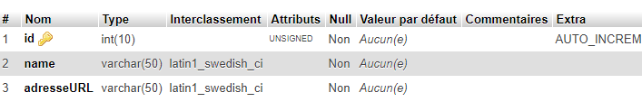
Insert

INSERT INTO EDITEUR (id,name,adresseURL)
VALUES
(1,'COCHRAME',''),
(2,'PUBMED',''),
(3,'MOTRIAL',''),
(4,'CORE','');
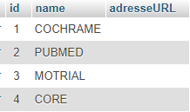

Select
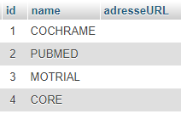
Select un champ | Select tous les champs
SELECT name  FROM editeur  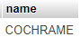  WHERE id = 1 | SELECT *  FROM editeur

Table HistoQuery

Création
CREATE TABLE Histoquery(
id INTEGER UNSIGNED NOT NULL AUTO_INCREMENT PRIMARY KEY,
name VARCHAR(50) NOT NULL,
description TEXT(1000) NOT NULL);

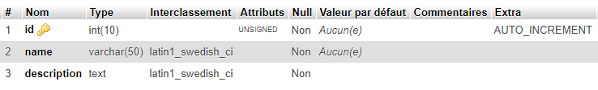
Insert

INSERT INTO Histoquery (id,name,description)
VALUES
(1,'Création table x','Permite crée une table sur la DBInm'),
(2,'Insert table x','Permite enregistrer d’information dans la table x'),
(3,'Select champ','Permite la sélection de l’information de la table x');

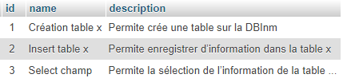
Select

Select un champ | Select tous les champs
SELECT name  FROM Histoquery  WHERE id = 1 | SELECT *  FROM Histoquery
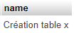
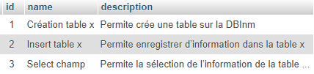
Table etudie

Création

CREATE TABLE etude (
titre VARCHAR(50) NOT NULL PRIMARY KEY,
auteurs VARCHAR(50) NOT NULL,
anneePubl_1 YEAR NOT NULL,
anneePubl_2 YEAR NOT NULL,
categorie VARCHAR(50) NOT NULL,
sous_categorie VARCHAR(50) NOT NULL,
maladie VARCHAR(50) NOT NULL,
nom_journal VARCHAR(50) NOT NULL,
pays VARCHAR(50) NOT NULL,
sponsor VARCHAR(50) NOT NULL,
lien TEXT(1000) NOT NULL,
nomDb VARCHAR(50) NOT NULL);
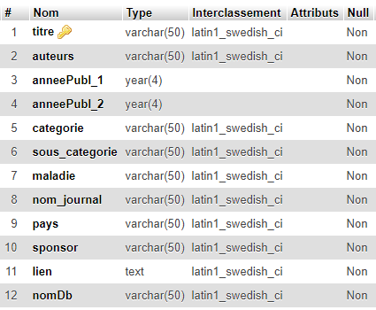

Insert

INSERT INTO etude (titre,auteurs,anneePubl_1,anneePubl_2,categorie,sous_categorie,maladie,nom_journal, pays,sponsor,lien,nomDb)
VALUES
(1,'Ceps',2020,2021,'Physiques','Thérapies manuelles','Neoplasms','xxxxx','France','La Région','xxxxxxx','PubMed');

Select

Select un champ | Select tous les champs
SELECT titre,categorie,sous_categorie,maladie  FROM etude  WHERE anneePubl_1 = 2020 | SELECT *  FROM etude
